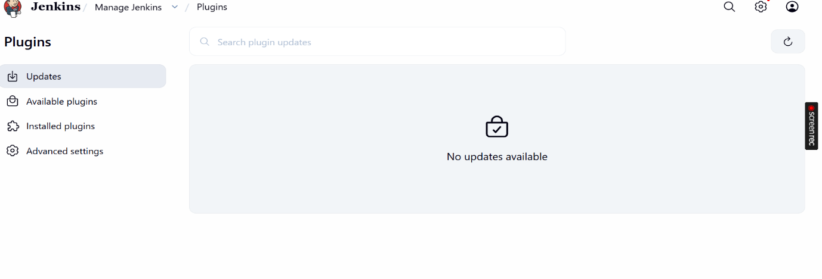

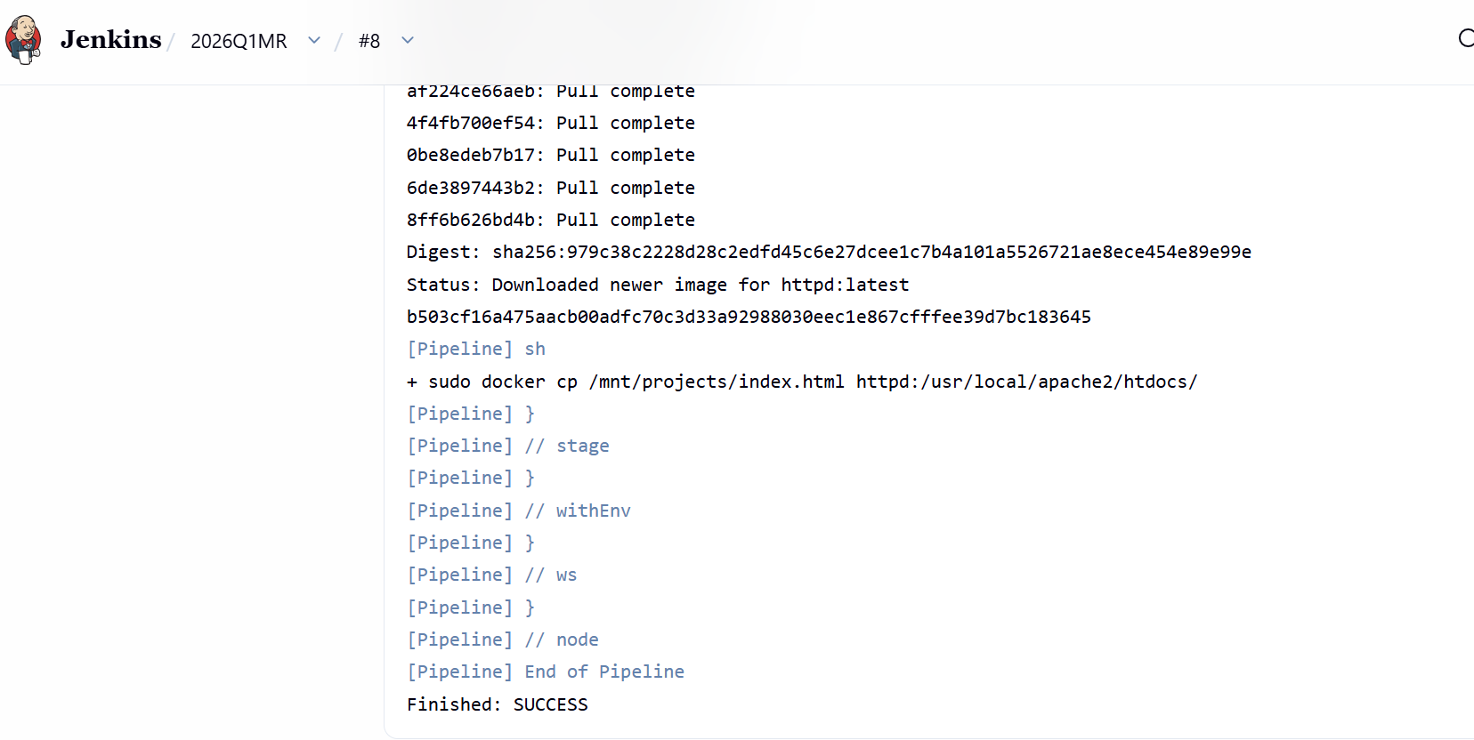

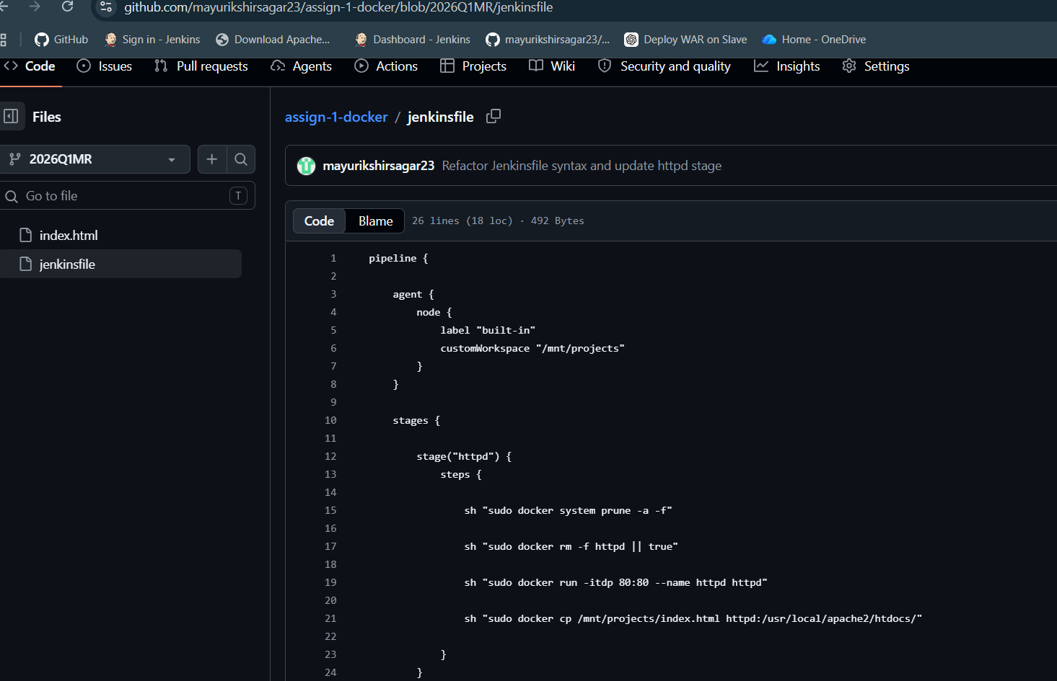
For a)PIPELINE steps followed are-
Step 1-create a Jenkins pipeline script as shown above
Checkout=Pull Docker Image=Stop Old ContainerRun HTTPD Container-Deploy index.html-Verify.
Step 2-run pipeline on github jenkinsfile=
Step 3-add docker tools on Jenkins,add plugin of docker,then build without adding pipeline in Jenkins ,add repo url,file name of repo i.e jenkinsfile
Step 4-verify docker = we should see httpd
Step 5-verify from browser = open-httpd://YOUR-EC2-PUBLIC-IP

Flow- github
---Index.html
2026Q1MR BRANCH
Jenkins
---------freestyle
---------pipeline
|
Deploy in Container

httpd

